react styling and css

In React, styling can be approached in various ways. The two primary methods are:

**1.Inline Styles:**

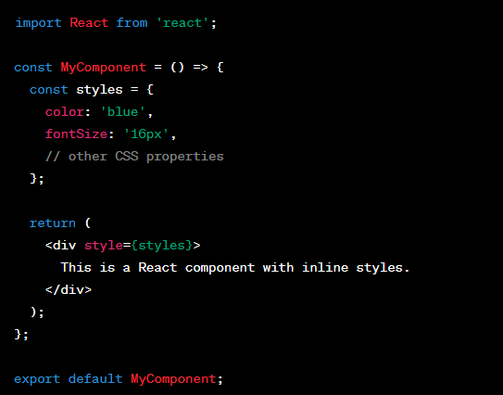

2.CSS-in-JS Libraries:

Another approach is to use CSS-in-JS libraries that allow you to write styles in JavaScript. Popular libraries include Styled-components, Emotion, and CSS Modules.

